4-2 Milestone Three: Enhancement Two: Algorithms and Data Structures

Joshua M James

Southern New Hampshire University

CS 499: Computer Science Capstone

Prof. Brooke

March 31, 2024

4-2 Milestone Three: Enhancement Two: Algorithms and Data Structures

1. Briefly describe the artifact. What is it? When was it created?

The Artifact I'm going to look at is my inventory application. The goal of this application is to track inventory items. This application was developed within android studio using java featuring an SQLite database. This application was from my CS 360 Mobile Architecture and Programming course and was created last term.

2. Justify the inclusion of the artifact in your ePortfolio. Why did you select this item? What specific components of the artifact showcase your skills and abilities in algorithms and data structure? How was the artifact improved?

Selecting my inventory application for the algorithms and data structures justifies the inclusion for my ePortfolio. Implementing the linear search functionality enhances my inventory application by enabling users to locate a specific item. This enhancement shows my proficiency in algorithm design, particularly through the implementation of the linear search algorithm. Additionally, integrating the search bar and interacting with the RecyclerView demonstrates my skills in UI/UX design and event handling. The artifact was improved by enhancing the user experience with search functionality, addressing a limitation I had with my original application.

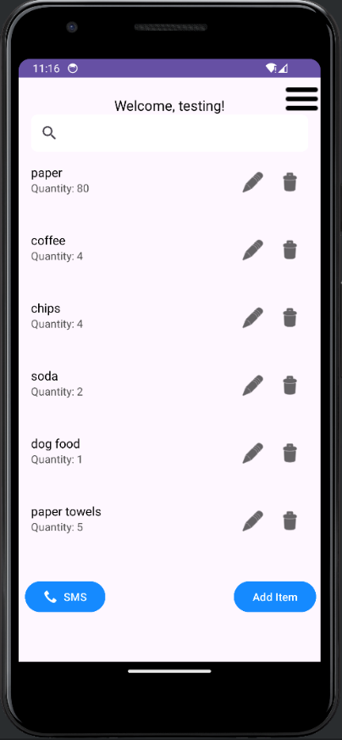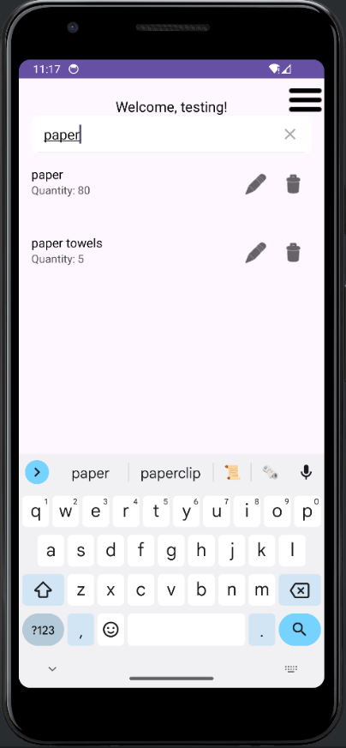

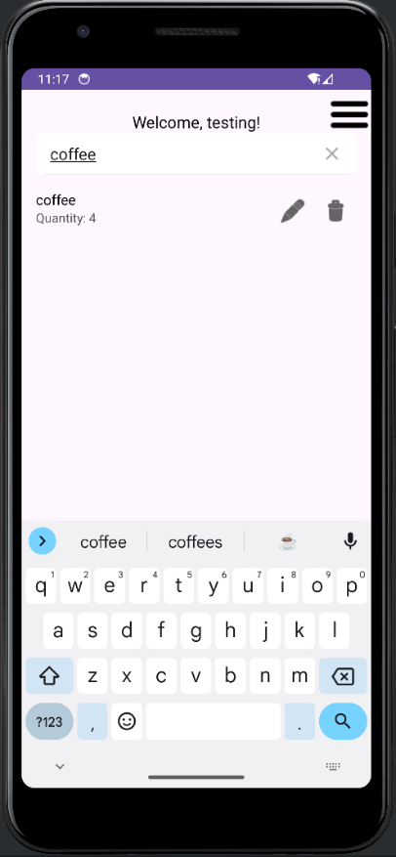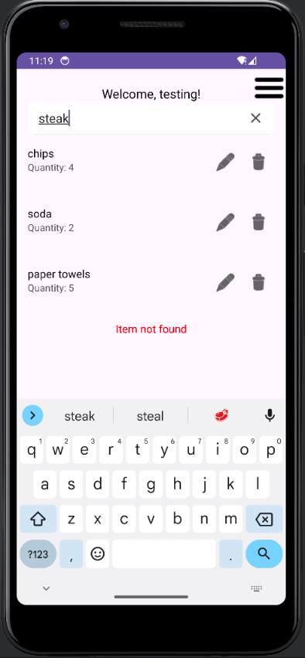

3. Did you meet the course objectives you planned to meet with this enhancement in Module One? Do you have any updates to your outcome-coverage plans?

With the addition of search functionality on my inventory screen, I was able to meet the course objective planned in module one. This enhancement aligns with:

* Designing and evaluating computing solutions that solve a given problem using algorithmic principles and computer science practices and standards appropriate to its solution while managing the trade-offs involved in design choices.

I was faced with the problem where if a user were to have a large inventory list, there was no current way to search for a specific item. Having an SQLite database already, that saves a user's items to their own unique dataset based on login information, there was a need for an effective solution to enhance the user experience. Implementing the linear search algorithm allows to iterate through a user's items from the dataset in the database efficiently. I was able to achieve this by using the linearSearch method iterating through the itemList and checking if each item's name contains the query string. If the match is found the item is, then added to the searchResultsList. The time complexity of the linear search method is O(n) since the array is completed once, where n is the number of items in the list. Best case complexity is O(1) and worse cases is O(n). Finally, the searchResults are returned with the items that match the search. Overall time complexity of the onQueryTextChange is also O(n), where n is the number of items in the original list (originalItemsList). The linear search grows linearly with the number of items in the users lists. In this enhancement I managed trade-offs as well by considering algorithm efficiency, user experience and the implementation of the algorithm itself.

Ensuring a user-friendly search bar with a linear search algorithm, I was able to:

* Demonstrate my ability to use well-founded and innovative techniques, skills, and tools in computing practices for the purpose of implementing computer solutions that deliver value and accomplish industry-specific goals.

Allowing the user to filter items efficiently enhances the user experience and shows my ability in software development with an innovative approach. This algorithm is a commonly used algorithm used in applications due to its simplicity and effectiveness. Utilizing Android Studios SDK, I was able to integrate the search algorithm with a RecyclerView and a SearchView to create a user-friendly interface which aligns with industry standards. This enhancement added value to my current application, improving the overall usability all while accomplishing industry-specific goals. As well as making sure to follow best practices by providing “item no found” message when no item has been found from the search, including.

4.Reflect on the process of enhancing and modifying the artifact. What did you learn as you were creating it and improving it? What challenges did you face?

Enhancing and modifying the artifact, partially in implementing the search functionality, allowed me to learn and gain knowledge. Specifically in the process I was able to learn about using RecyclerView. RecyclerView is built within the Android Studio SDK and designed to display large sets of data. It works by recycling views moving in and out of the user’s view. With the learning process I was able to get an understanding of how linear search algorithm and the RecylerView work together for my enhancement. The linear search algorithm was applied to the dataset in my database for inventory items, then the RecylerView updates the dataset in a real time display for the user. When working on my enhancement, I faced a few challenges. Initially when adding the search functionality as well as the RecylerView, I had issues with the RecylerView itself and not the linear search algorithm. The RecylerView was only displaying one item from the user inventory database even though there were multiple items. The problem occurred because I had an improper set up of the adapter. Another challenge I faced was when deleting an inventory item from the list. I found that although deleting an inventory item removed it from the database as expected, the deleted item would reappear in the list when searched. After reviewing my code, I realized that I was not updating the originalItemsList whenever the new itemList was being modified.